Instructions on How to Use the Code
There are two files in the zipped folder, first one is called “Salary Func” this is the jupyter notebook containing the code that helps to find details about an employee and print that detail into a dataframe, converts it into a dictionary and also save the dataframe in CSV(comma separated values) file
The codes in the Jupyter notebook can easily be run from the local host server if you are using Anaconda
Using anaconda
The jupyter notebook should already be installed in anaconda application, go on there, locate the jupyter notebook(fig 1 below) and click launch, it should automatically bring you to the local host server(fig 2 below) in your default browser, where you can locate the downloaded and extracted file
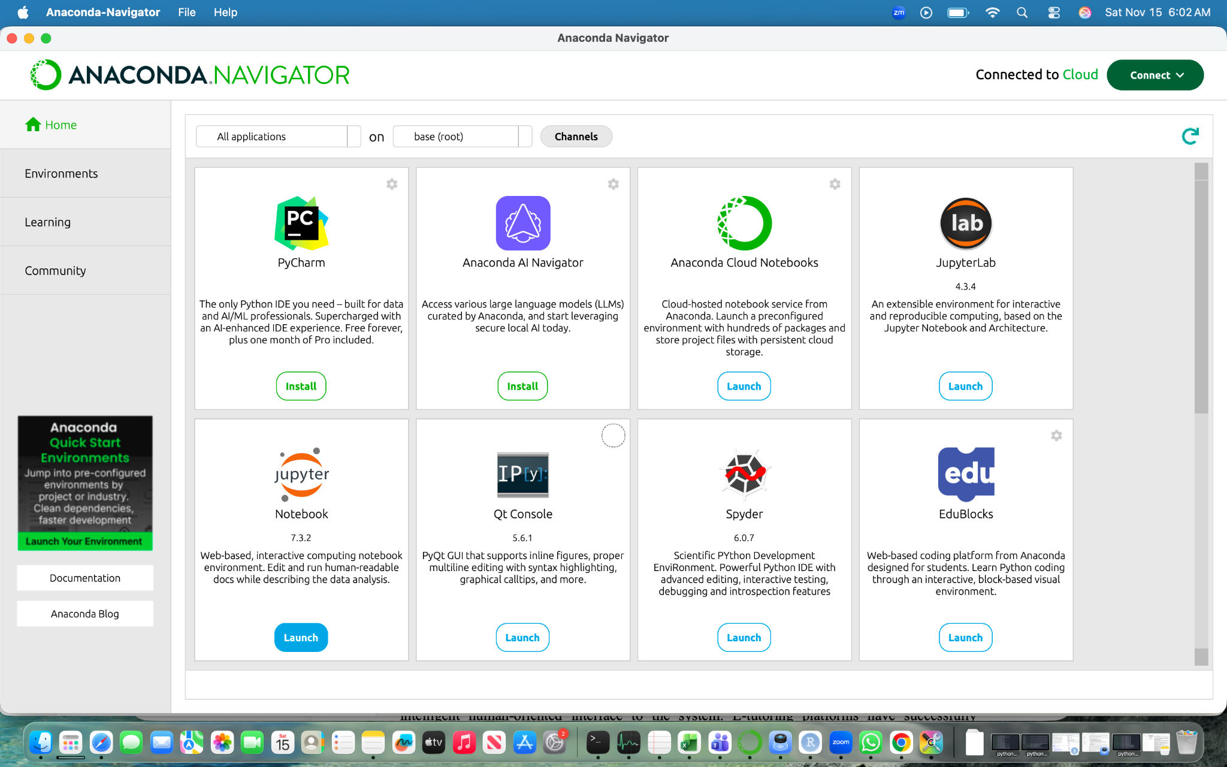

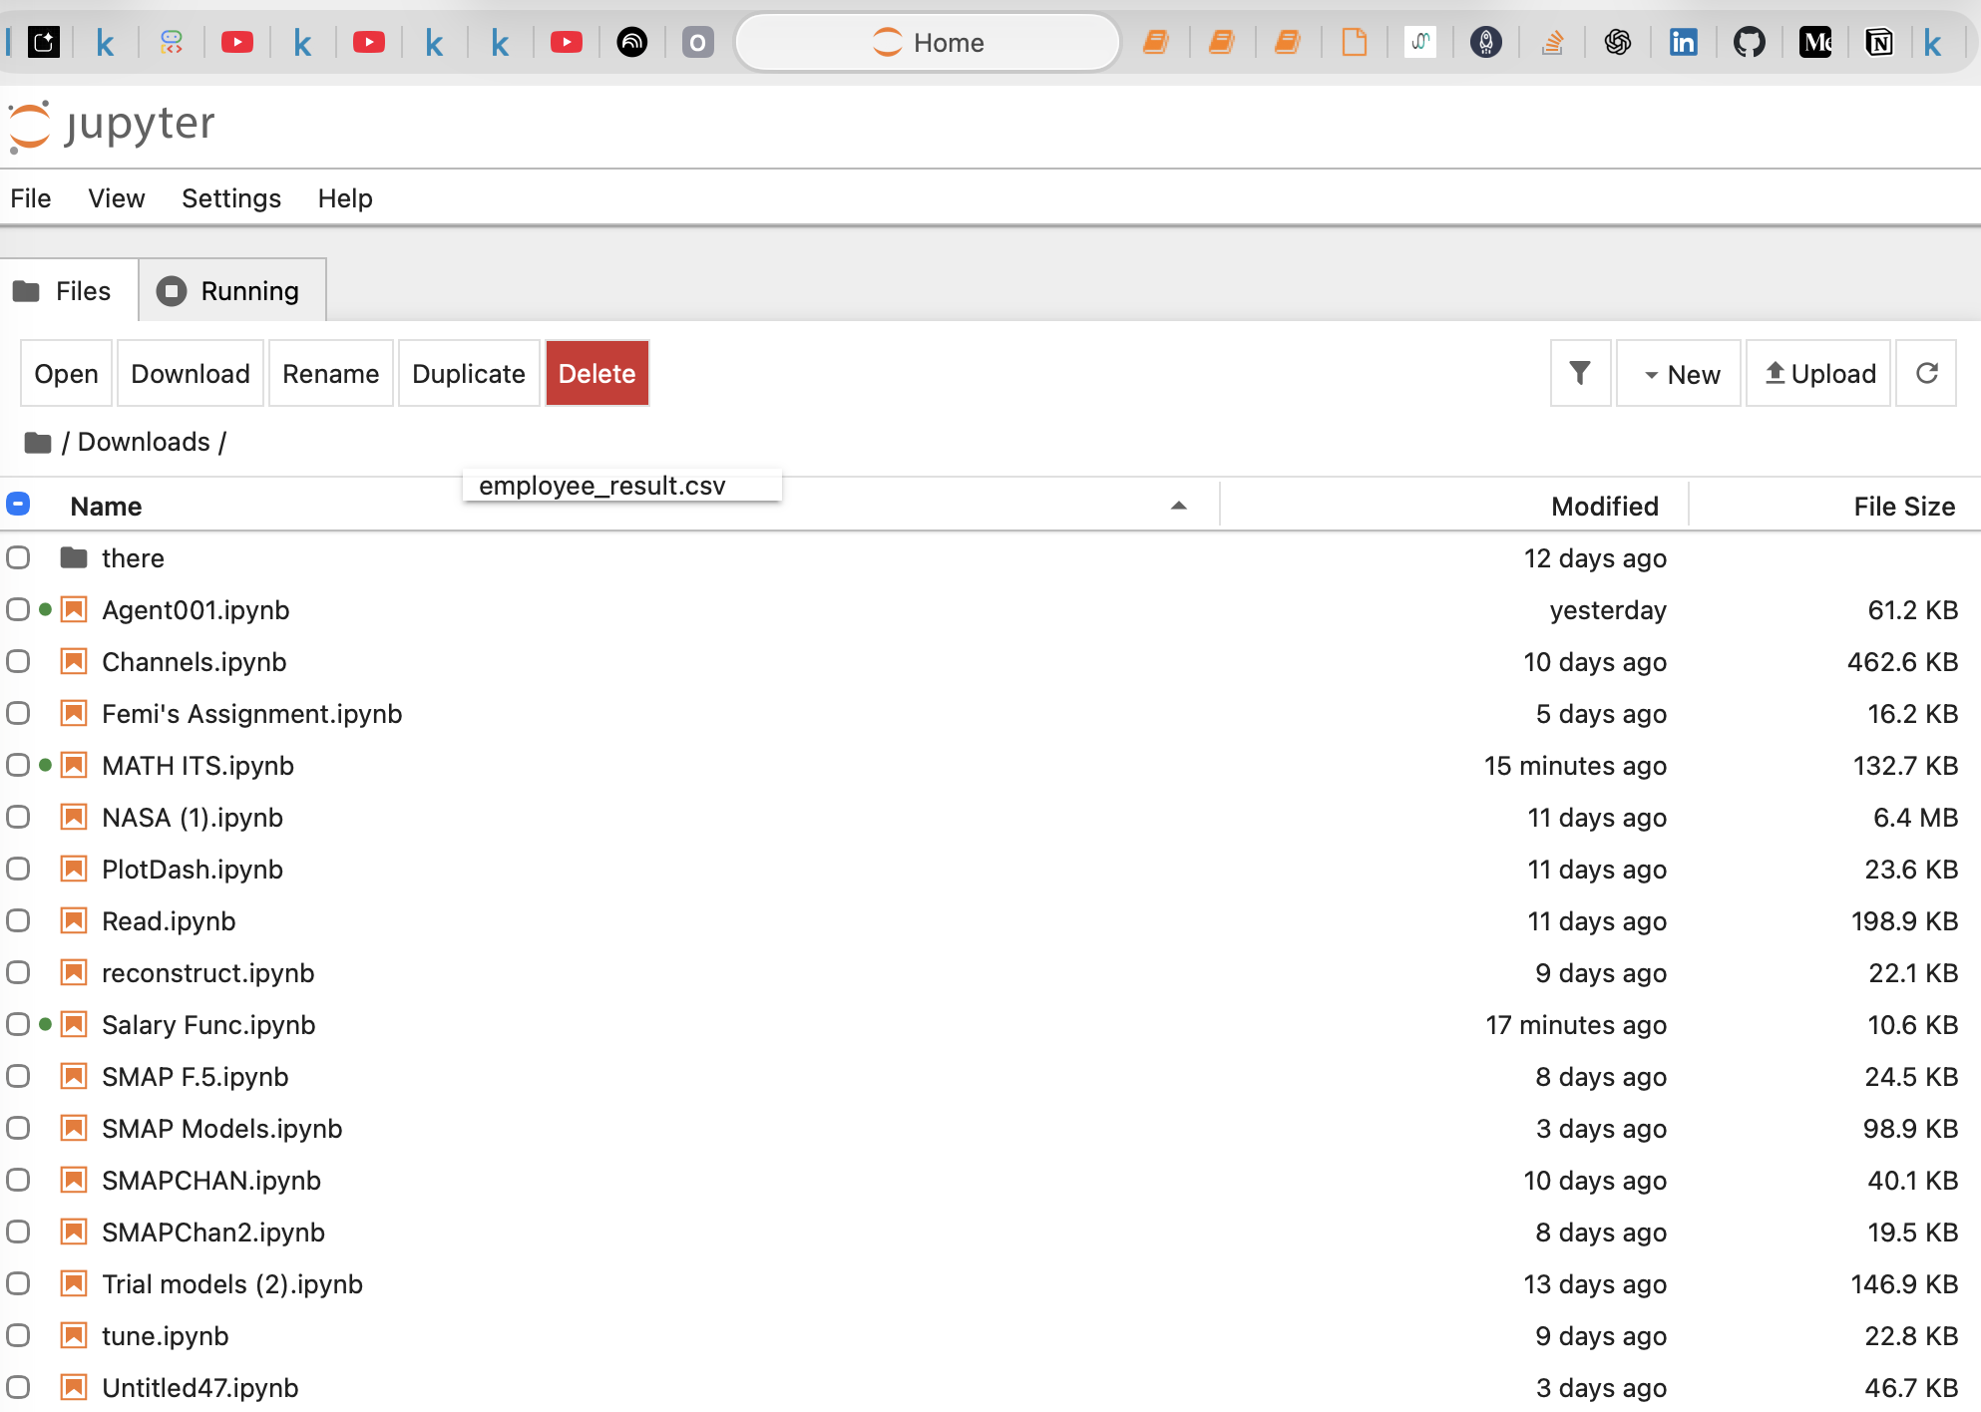

Make sure file has been extracted(unzipped), When you locate the notebook titled “SalaryFunc” simply open it and run all cells to use the code

To use “R” to unzip the zip employee csv file and to display
After the python code has run and the csv file saved in a zipped folder, All you need to do is open the R script in the folder and run the code in Rstudio environment and the result should be displayed in the console. Just like in the image below